**ABSTRACT**

Present state of the environment is getting worse day by day, the most basic reason being the pollution due to petrol/diesel vehicles. So we use Electric vehicle as a solution, which have zero harmful emissions. By 2030, 60% of the vehicles will be Electric Vehicles Companies have to shift their existing infrastructure to support the EV charging at work, which can be cost and time intensive. Overall charging infrastructure needs to be installed all over the city like petrol pumps. The increased number of EVs and their random charging pattern along with the normal household usage causes sudden energy peaks which might lead to grid failure and regular high peaks of load. This rise in peak can cause grid failure and blackouts. We need to minimise the peak cause due to random EVs charging.

We propose an Adaptive Management of EV Charging algorithm which is implemented through a learning agent that acts on behalf of individual EV owners and schedules EV charging over a week. Our agent uses Reinforcement Learning trained on real world data to learn individual household consumption behaviour and to schedule EV charging. It accounts for individual preferences so that mobility service is not violated but also individual benefit is maximized. We show that AMEVS achieves significant reshaping of the energy demand curve and peak reduction, which is correlated with customer preferences regarding perceived utility of energy availability and we show that the average peaks got reduced after using the proposed algorithm for EV charging.

|  |  |  |
| --- | --- | --- |
| **S.NO** | **TOPICS** | **Page No.** |
| **1** | **Introduction**  1.1 Electric Grid  1.2 Smart Grid  1.3 Electric vehicles | 1-3 |
| **2** | **Related Work** | 4 |
| **3** | **Problem Statement** | 5 |
| **4** | **Methodology**  3.1 Reinforcement Learning  3.2 EV Customer Agent  3.3 Driving Profile  3.4 Statistical Model for EV Customer Agent  3.5 Whittle Index Policy | 563535444  6-9 |
| **5** | **Experimental Evaluation**  4.1 Benchmark Algorithm  4.1.1 Uncontrolled Charging  4.1.2 Heuristic Charging | 10-12 |
| **6** | **Results**  5.1 Peak Caused due to Uncontrolled Charging  5.2 Peak Minimised through Heuristic Charging  5.3 Comparison b/w Heuristic and Uncontrolled Charging | 13-15 |
| **7** | **Conclusion** | 16 |
| **8** | **References** | 17 |
| **9** | **Appendix-I** | 18-19 |
| **10** | **Appendix-II** | 20-21 |

**CHAPTER 1**

**INTRODUCTION**

* 1. **Electrical Grid**

An electrical grid is an interconnected network for delivering electricity from producers to consumers. It consists of generating stations that produce electrical power, high voltage transmission lines that carry power from distant sources to demand centres, and distribution lines that connect individual customers. The electricity grid is a complex and incredibly important system, and one of the most impressive engineering feats of the modern era. It transmits power generated at a variety of facilities and distributes it to end users, often over long distances. It provides electricity to buildings, industrial facilities, schools, and homes. And it does so every minute of every day, year-round.

**1.2 Smart Grid**

 The digital technology that allows for two-way communication between the utility and its customers, and the sensing along the transmission lines is what makes the grid smart. Like the Internet, the Smart Grid will consist of controls, computers, automation, and new technologies and equipment working together, but in this case, these technologies will work with the electrical grid to respond digitally to our quickly changing electric demand.

Many government institutions around the world have been encouraging the use of smart grids for their potential to control and deal with global warming, emergency resilience and energy independence scenarios.

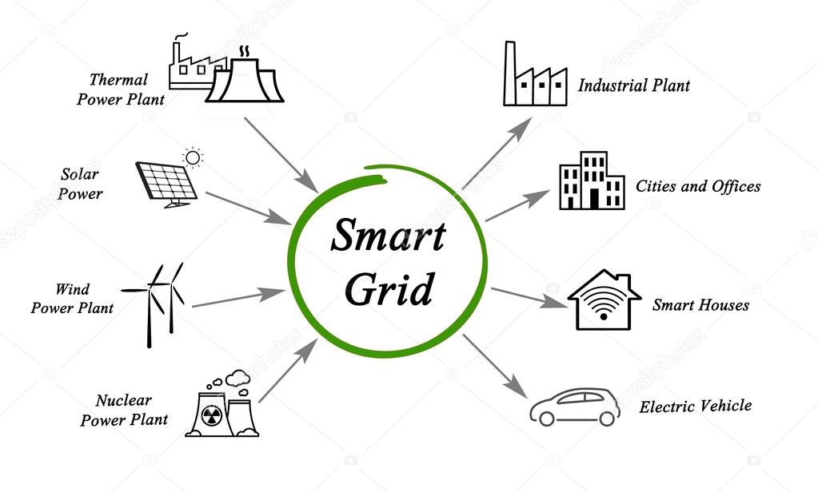

Fig(1.2) Sources Connected to Smart Grid

A modern smart grid system has the following capabilities:

* It can repair itself.
* It encourages consumer participation in grid operations.
* It ensures a consistent and premium-quality power supply that resists power leakages.
* It allows the electricity markets to grow and make business.
* It can be operated more efficiently

**1.3 Electric Vehicles (EVs)**

An EV, also referred to as an electric drive vehicle, is a vehicle which uses one or more electric motors for propulsion. Depending on the type of vehicle, motion may be provided by wheels or propellers driven by rotary motors, or in the case of tracked vehicles, by linear motors. Electric vehicles can include electric cars, electric trains, electric trucks, electric lorries, electric airplanes, electric boats, electric motorcycles and scooters, and electric spacecraft.

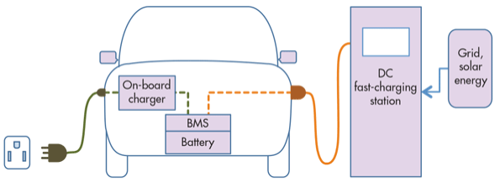

**Fig(1.3) Charging Station Block Diagram of Electric Vehicles**

An electric car is an alternative fuel automobile that uses electric motors and motor controllers for propulsion, in place of more common propulsion methods such as the internal combustion engine (ICE). Electricity can be used as a transportation fuel to power battery electric vehicles (EVs). EVs store electricity in an energy storage device, such as a battery. EVs have limited energy storage capacity, which must be replenished by plugging into an electrical source.

**CHAPTER 2**

**RELATED WORK**

In (Akasiadis and Chalkiadakis 2013) the authors proposed an algorithm for creating customer cooperatives so that peaks in energy demand are reduced and the grid is benefited by this formation. In (Stein et al. 2012) the authors described an online mechanism with pre-commitment for coordinating the EV charging. In (Valogianni, Ketter, and Collins 2014) an EV charging strategy is analyzed without assuming V2G capabilities and without formalizing the customers’ preferences. Finally, in (Vandael et al. 2013) a three step approach to coordinate EV charging is presented, being scalable and achieving demand shifting. All previous works coordinate the charging from the point of view of an external party (charging coordinator) whereas in the current work we present a fully distributed approach without any external coordinator.

We propose an Adaptive Management of EV Charging algorithm which is implemented through a learning agent that acts on behalf of individual EV owners and schedules EV charging over a week. Our agent uses Reinforcement Learning trained on real world data to learn individual household consumption behaviour and to schedule EV charging. It accounts for individual preferences so that mobility service is not violated but also individual benefit is maximized. We show that AMEVS achieves significant reshaping of the energy demand curve and peak reduction, which is correlated with customer preferences regarding perceived utility of energy availability and we show that the average peaks got reduced after using the proposed algorithm for EV charging.

**CHAPTER 3**

**PROBLEM STATEMENT**

With the universal resurgence of Electric Vehicles (EVs) the adverse impact of the EV charging loads on the operating parameters of the power system has been noticed. The detrimental impact of EV charging station loads on the electricity distribution network cannot be neglected. The high charging loads of the charging stations results in increased peak load demand and reliability problems.

The EV owner

This project aims to investigate the impact of the EV charging station loads on the the distribution network. The increased number of EVs and their random charging pattern along with the normal household usage causes sudden energy peaks which might lead to grid failure and regular high peaks of load. This rise in peak can cause grid failure and blackouts. We need to minimise the peak cause due to random EVs charging.

**CHAPTER 4**

**METHODOLOGY**

**4.1 Reinforcement Learning**

Reinforcement Learning is a type of Machine Learning. Machine learning is an application of artificial intelligence (AI) that provides systems the ability to automatically learn and improve from experience without being explicitly programmed. It allows machines and software agents to automatically determine the ideal behaviour within a specific context, in order to maximize its performance. Simple reward feedback is required for the agent to learn its behaviour; this is known as the reinforcement signal.

In the problem, an agent is supposed decide the best action to select based on his current state. When this step is repeated, the problem is known as a Markov Decision Process. The input module gets as inputs all the individual characteristics of each customer (gender, profession, daily routine etc.) as well as the customer’s driving profile and the utility function. The learning module is responsible for learning the individual household consumption using RL. Finally the optimization module taking inputs from the other two modules, optimizes

the charging and discharging.

**4.2 EV Customer Agent**

The proposed customer model focuses on EV owners and simulates their driving and charging behaviour. More specifically, simulates each individual driving behaviour and distance for various activities performed per day, as well as the household energy consumption behaviour. Regarding charging, we assume initially only regular charging without having any fast charging. We plan to integrate fast charging capabilities later on. However, this addition will create higher challenges, since the demand peaks will be higher (i.e. higher demand at shorter time). An important factor in modelling the EV owners is their driving profile. This profile directly determines the battery capacity that a customer needs for driving and consequently the capacity available to offset supply-demand imbalances. The population is divided according to gender and the social groups that comprise the total population. Those social groups with their

special characteristics are: part-time employees, full-time employees, students and pupils, unemployed.

Second step in the modelling process is the day determination (weekday or weekend). Having determined the activities related to each group considering the day, we create driving profiles corresponding to the distance that each customer drives per day. We assume that the customers in our population own purely electric cars like Nissan Leaf.

The minimum charge level, the customer expects to have available for unplanned use of the vehicle, expresses customer’s risk attitude towards range anxiety. Customers who are risk averse, want their EV fully charged as soon as possible after it’s plugged in, and never want the charge to be less than 100% once it’s charged. On the other hand totally risk seeking customers expect just the amount needed for planned driving at the times they plan to drive.

Customer agent

Input Module Learning Module Optimisation Module

Each customer agent consists of an input module, a learning module and an optimization

module :

* The **input module** gets as inputs all the individual characteristics of each customer

(gender, profession, daily routine etc.) as well as the customer’s driving profile and the

utility function.

* The **learning module** is responsible for learning the individual household consumption

using RL.

* Finally the **optimization module,** taking inputs from the other two modules, optimizes

the charging and discharging.

**4.3 Driving Profile**

Each customer have a unique driving pattern, keeping that in mind we create driving profiles corresponding to the distance that each customer drives per day (assuming average driving speed). We determine the customer’s EV type and consequently the respective storage capacity. The population is divided according to gender and the social groups: part-time employees, full-time employees, students and pupils, unemployed and retired persons.

E{Distt} = LT(G(k), H(k))

Where, E{Dist} is the estimated distance to be travelled upto time **t** , G(k) Customer group describing the type of customer they are, ex: working professional, student etc and H(k) is the Customer Activity i.e. whether he uses the vehicle for, is he a regular or not. LT is a look-up table function that has as inputs the social group and the activity and as output the expected average distance.

Ct= Ct-1 − E{Distt} · ρ

where Ct is the battery’s state of charge up to timeslot t, and ρ is the capacity/distance rate given by the automotive companies.

**4.4 Statistical Model for EV Customer Agent**

A brief overview of methodology to compute the charging required by taking input from the customer agent is presented in this section.

Price History

(P)

Customer Group

(Gk)

Look-up Table

(LT)

Customer

Activities

(Hk)

Capacity/Distance rate(q)

Expected distance

until time

t(E{dist(t)})

Smart Charging

State of charge

C(t)

Fig (4.4).Flow Chart for Smart Charging

**4.5 Whittle Index Policy**

To select the order of the EVs that are to be charged first we use an indexing policy called whittle policy. Whittle policy is an algorithm which takes various inputs to give a sorted output. The Markov Distribution Problem formulation does not result in a scalable scheduling policy. As the load is independent conditioned on cost, we seek to obtain an index policy that provides a scalable solution. We plan to insert whittle into heuristic approach for more optimised charging By index policy we mean that the scheduling is based on the ranked order of indices associated with loads. We provide this ranking by taking the data from the customer ID

We segment the priority of three segments :

* Urgency of charging (U) - 20
* Charging Requirement (Ch) – 20
* Recharge accepting Rate(A) – 10

$Wk=\sum{(\frac{U}{20}+\frac{W}{20}+\frac{A}{10})}$..... (1)

where, U is the charging urgency based of the Customer ID, Ch is the charging requirement of the car till the next time slot, A is the Acceptance charge rate of the battery.

We use this whittle index and Customer ID(that will be generated over period of time) to

prioritise the charging.

This will enable us to minimise the load on the grid because at a time, only the most prior cars

will be charged.

**CHAPTER 5**

**EXPERIMENTAL EVALUATION**

We evaluate AMEVS (Adaptive Management Of Electric Vehicles Storage) in different populations and examine its effect on the individual demand curve but also on an aggregate level of peak demand and price reduction. We see that the adoption of AMEVS by all the customer agents leads to peak demand and price reduction on the market. This means that AMEVS achieves an implicit coordination of charging without the presence of an actual coordinator. Further, we examine how AMEVS influences the EV charging landscape as a function of the EV ownership penetration.

Here we are using two Benchmark algorithms:

* + **Charging without Policy-Uncontrolled Charging**
  + **Charging with policy-Heuristic Charging**

**5.1 Benchmark Algorithm**

In statistical learning benchmarking is the methodology of comparing learners or algorithms with respect to a certain performance measure.

**5.1.1 Uncontrolled Charging**

This algorithm charging the car fully at a time on first come first served basis

**Benchmark Algorithm 1(Worst Scenario) – Uncontrolled Charging (UC)**

1. Initialisation
2. For t 1:N
3. Calculate CAt, E{Distt}
4. If CAt==TRUE & Ct<E{Distt}.p
5. Dt=xh,t+xc,t
6. endif
7. endfor
8. return D

**Terms defined**

CAt : Charging Availability**,** E{Distt}.p :Expected capacity needed for driving upto timeslot t,Xh,t and Xc,t are the household and vehicles charging demand over time respectively,D: Total demand,p : Capacity/Distance for Nissan Leaf it is 15kw/100km,N: Time(in hours) available for charging

This algorithm charging the car fully at a time on first come first served basis. Now, to improvise our algorithm we have developed new algorithm named Heuristic Charging approach.

**5.1.2 Heuristic Algorithm**

It predicts the prices over a time horizon consisting of N time slots. Here, we compare the current energy demand with the predicted energy demand

And it is simply ,if predicted demand is more than current demand we will charge the cars fully in current time horizon otherwise we divide the charging requirement equally in N time slots and this whole process will be observed at each time horizon.

**Benchmark Algorithm 2(Best Scenario)-Heuristic Charging (HC)**

1. Initialisation
2. For t=1:N
3. Calculate CAt, E{Distt}
4. E{Distt}.p=Req
5. If (Reqt < Reqt+1)& Ct<E{Distt}.p
6. Xc,t =[max x­c,t] Charge car completely in this slot
7. Else
8. Xc,t =[max x­c,t/N] (Split the charging in N time slots)
9. Endif
10. Dt=xh,t+xc,t
11. endfor
12. return D

Heuristic Model

**Input**

**(Reqt,E(dist),Reqt+1)**



FALSE

Split the charging in N time slots.

X(c,t) = [max X(c,t)]/N

TRUE

Charge Now

X(c,t) = max X(c,t)

Fig 5.1.2 Flowchart for Optimised Heuristic Model for EV Charging

**CHAPTER 6**

**RESULTS**

**6.1 Result when using Uncontrolled Charging Algorithm leading to peak generation in Energy Demand Curve.**

Load profile for the uncontrolled charging of electric vehicles and household consumption is shown in fig 6.1

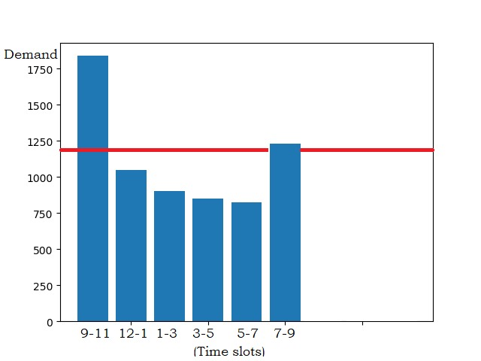

Fig (6.1)

* Time Intervals from 9:00 AM to 5.00 PM showing electricity usage by fleet of Electric Vehicle Customers at Charging Station.
* 1200 KW is Cut Off demand Charging Station can support easily.
* After 1200 KW, there is a peak generated in different time interval during peak hours of the day when electricity usage is very high by customers.

**6.2 Result when using Controlled Charging Algorithm i.e. Heuristic Charging leading to peak Reduction in Energy Demand Curve**

By implementation of Heuristic Algorithm, we are successfully able to compress the over loading caused due to high demand of charging electricity by electric vehicles customers shown in fig 5.2.

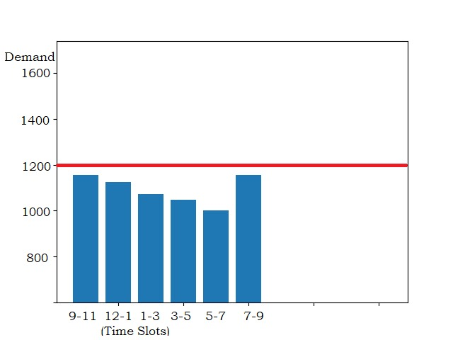

Fig (6.2)

**6.3 Comparison using Uncontrolled Charging and Heuristic Charging**

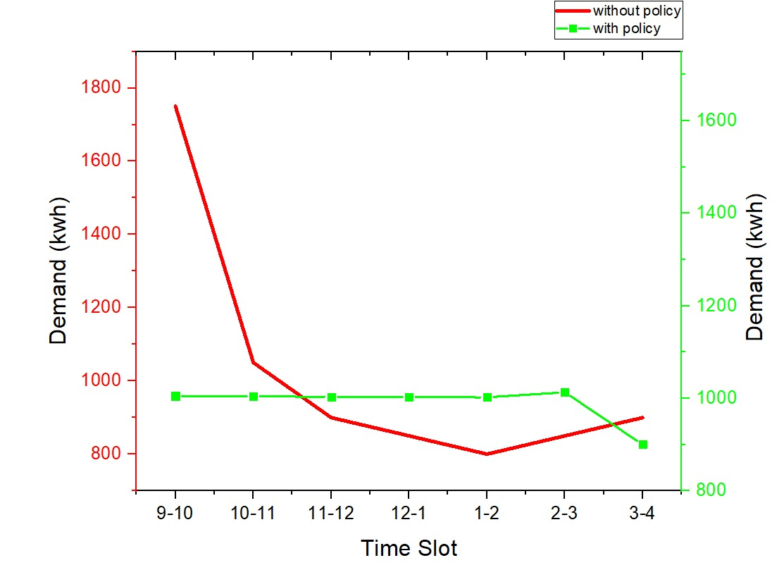

Fig(6.3)

**CHAPTER 7**

**CONCLUSION**

Electric Vehicles are most important part of the Smart Grid. If they are properly used in the market, they may yield significant benefits for the network and the energy users. However, the uncontrolled use of EVs may lead to energy crisis, due to peak in the energy demand. Thus, we propose an Adaptive Management of EV Storage (AMEVS) algorithm i.e Heuristic algorithm and whittle policy to mitigate the negative influence on social benefit and enhance the robustness and reliability of the grid. The average energy prices are reduced for all customers in the market with the use of AMEVS against the Uncontrolled Charging. Moreover, the unnecessary charging rising from customers range anxiety is significantly reduced promoting EVs adoption.

With the AMEVS algorithm, we are able to manage the energy demand by distributing charging demand by the customers over different time intervals and thus creating a optimised charging station leading to benefit of both Customer as well as Government perspective.

We can conclude from methods discussed :

Result-1

When use uncontrolled charging leads to overloading and causes grid failure.

Result-2

When use heuristic charging leads to minimising overloading peaks caused due to household and electric vehicles consumption.

**CHAPTER 8**

**REFERENCES**

**References**

1. [E.g., Minnkota Power's Load Management System](http://www.minnkota.com/Pages/loadmana.html), accessed 22 August 2009.
2. Graeme Gooday *The morals of measurement: accuracy, irony ,and trust in late Victorian electrical practice*, Cambridge University Press, 2004 [ISBN](https://en.wikipedia.org/wiki/International_Standard_Book_Number) [0-521-43098-4](https://en.wikipedia.org/wiki/Special:BookSources/0-521-43098-4), p 232–241
3. Whyte, Adam Gowans (1930). Forty Years of Electrical Progress. London: Ernest Benn. pp. 31
4. Eugenii Katz. [*"Blathy"*](https://web.archive.org/web/20080625015707/http:/people.clarkson.edu/~ekatz/scientists/blathy.html). People.clarkson.edu. Archived from [*the original*](http://people.clarkson.edu/~ekatz/scientists/blathy.html) on June 25, 2008*. Retrieved 2009-08-04*.
5. G.W.D. (March 1896). [*"Electricity Supply Meters"*](https://archive.org/stream/journal06sectgoog#page/n77/mode/1up). Journal of the Institution of Electrical E120)::*[10.1049/jiee-1.1896.0005](https://doi.org/10.1049%2Fjiee-1.1896.0005)*. Student paper read on January 24, 1896 at the Students' Meeting.
6. The Electrical engineer, Volume 5. (February, 1890)
7. The Electrician, Volume 50. 1923
8. Official gazette of the United States Patent Office: Volume 50. (1890)
9. W. Bernard Carlson, *Innovation as a Social Process: Elihu Thomson and the Rise of General Electric*, Cambridge University Press, 2003 [ISBN](https://en.wikipedia.org/wiki/International_Standard_Book_Number) [0-521-53312-0](https://en.wikipedia.org/wiki/Special:BookSources/0-521-53312-0).
10. <https://www.google.co.in/search?q=electric+vehicles+charging+infrastructure&rlz=1C1EJFA_enIN734IN734&source=lnms&tbm=isch&sa=X&ved=0ahUKEwir_vSpu_PaAhWMipQKHRNeBCkQ_AUICygC&biw=1242&bih=557#imgrc=QBY04wyL722WEM>:
11. http://students.ceid.upatras.gr/~papagel/project/kef5_5.htm

**Appendix-I**

**Code for peak due to Electric Vehicle and Household Usage**

import numpy

import matplotlib.pyplot as plt

import random

time = [9,10,11,12,1,2,3,4,5,6,7,8,9]

p=[1100,1050,900,850,825,800,1200,987,1000]

#demand of units from 9-11, 11-1....till 9pm

#Ct=[5, 4, 8, 3, 5, 4, 2, 5, 1, 0] #current state of charge from in kW 10 cars

#Edist = [70, 90, 78, 45, 52, 46 , 23, 100, 74, 90] # distance to be traveled by each of the 10cars in km

#wk= [.4, .9, 1, .1, .6, .5, .5, .7, .9, .3] #random whittle index alloted

Ct=[]

Edist=[]

wk=[]

for x in range (100):

Ct.append(random.randint(0,10))

Edist.append(random.randint(50,120))

wk.append(random.randint(1,10))

#print "following are the randomly generated values"

#print "random current state of chargings"

#print Ct

#print "random distance to be travelled"

#print Edist

#print "random whittle index"

#print wk

q = .15 # charge consumption per 100 km ie 15kWh/100km and this divided by 10 for making it within 0-1

swk=[]

swk= numpy.argsort(wk)[::-1] #this is sorting all the 10 cars according to their whittle index in descending order and returning their list index

wid=[]

#print 'the ids with descending order of priority is \n ', swk

for i in range(0,5):

wid.append(swk[i])

#print 'top 5 car to be charged have the follwing id $$$$$$$$$$$$$$$: \n', wid # this is trimming the first 5 top whittle indexes because we have 5 slots only

rsum=0

rq = [] # list initialised for calculating the requirement parameter

diff = [] # list initialised for calculating the actual required amount

for i in range(0, 100, 1):

r = q*Edist[i]

rq.append(r)

d=rq[i]-Ct[i] # d is difference of req charge - current state of charge

diff.append(d)

rsum=rsum+d

print "here is the total required energy////////////////", rsum

#print '\n the total energy required by all cars is%%%%%%%%%%%%%%%%%%%%%%%%%%%%%%%%%%%%%%%%%%%%%: ' , rsum

#print '\n this is the total till next day requirement \n', rq, '\n '

#print 'this is the amount of KW car needs to be charged \n', diff, '\n'

Slot sum=[0,0,0,0,0,0,0,0,0,0]

#print 'the sum of kws in each slot due to EVs are ' ,slot sum

i=0

peak=0

#print "this is creating problem:::::q3rqfzf234324132", diff

for i in wid: # charging starts with the once having the highest whittle index

#print '---------------the car currently being charged has ID : ', i, '-----------------------\n'

j=0

#if(diff[i]>0 and p[i]<p[i+1]):

while(diff[i]>0):

if(p[j]<p[j+1]):

# print '............................................'

# print j, ' is present time slot is \n'

# print 'this car charges now completely with ID', i

#print '............................................'

peak=slotsum[j]+diff[i]

slotsum[j]=peak

break

else:

#print '............................................'

#print j ,'is the present time slot \n',

#print 'initial diff in kw ', diff[i]

c=diff[i]/6

#print ' the portion of charging to take place in kw in this slot is \n', c

diff[i]=diff[i]-c #remaining charging to be done in the other slots

#print 'charge left is \n', diff[i]

#print '............................................'

peak=slotsum[j]+c

slotsum[j]=peak

j=j+1

#for i in slotsum:

#print '\n the sum of energy required in each of the slots are', i

#print ' now showing the plot'

#plt.bar([1,2,3,4,5,6,7,8,9,10], slotsum)

#plt.axis([0, 12, 1, 30])

#plt.show()

p=[1100+rsum,1050,900,850,825,800,1200,987,1000]

plt.bar([1,2,3,4,5,6,7,8,9],p)

plt.show()

Appendix-II

**Code for Pricing Policy**

import numpy

import matplotlib.pyplot as plt

import random

time = [9,10,11,12,1,2,3,4,5,6,7,8,9]

p=[9,8,8,7,10,9,8,9,8]

#p=[1300,1200,900,850,825,800,1200,987,1000] #demand of units from 9-11, 11-1....till 9pm

#Ct=[5, 4, 8, 3, 5, 4, 2, 5, 1, 0] #current state of charge from in kW 10 cars

#Edist = [70, 90, 78, 45, 52, 46 , 23, 100, 74, 90] # distance to be traveled by each of the 10cars in km

#wk= [.4, .9, 1, .1, .6, .5, .5, .7, .9, .3] #random whittle index alloted

Ct=[]

Edist=[]

wk=[]

for x in range (100):

Ct.append(random.randint(0,10))

Edist.append(random.randint(50,120))

wk.append(random.randint(1,10))

print "following are the randomly generated values"

print "random current state of chargings"

print Ct

print "random distance to be travelled"

print Edist

print "random whittle index"

print wk

q = .15 # charge consumption per 100 km ie 15kWh/100km and this divided by 10 for making it within 0-1

swk=[]

swk= numpy.argsort(wk)[::-1] #this is sorting all the 10 cars according to their whittle index in descending order and returning their list index

wid=[]

print 'the ids with descending order of priority is \n ', swk

for i in range(0,5):

wid.append(swk[i])

print 'top 5 car to be charged have the follwing id $$$$$$$$$$$$$$$: \n', wid # this is trimming the first 5 top whittle indexes because we have 5 slots only

rsum=0

rq = [] # list initialised for calculating the requirement parameter

diff = [] # list initialised for calculating the actual required amount

for i in range(0, 100, 1):

r = q*Edist[i]

rq.append(r)

d=rq[i]-Ct[i] # d is difference of req charge - current state of charge

diff.append(d)

if(i<5):

rsum=rsum+d

#print '\n the totak energy required by all cars is%%%%%%%%%%%%%%%%%%%%%%%%%%%%%%%%%%%%%%%%%%%%%: ' ,rsum

print '\n this is the total till next day requirement \n', rq, '\n '

print 'this is the amount of KW car needs to be charged \n', diff, '\n'

slotsum=[0,0,0,0,0,0,0,0,0,0]

print 'the sum of kws in each slot due to evs are ' ,slotsum

i=0

peak=0

print "this is creating problem:::::q3rqfzf234324132", diff

for i in wid: # charging starts with the once having the highest whittle index

print '---------------the car currently being charged has ID : ', i, '-----------------------\n'

j=0

#if(diff[i]>0 and p[i]<p[i+1]):

while(diff[i]>0):

if(p[j]<p[j+1]):

print '............................................'

print j, ' is present time slot is \n'

print 'this car charges now completely with ID', i

print '............................................'

peak=slotsum[j]+diff[i]

slotsum[j]=peak

break

else:

print '............................................'

print j ,'is the present time slot \n',

print 'initial diff in kw ', diff[i]

c=diff[i]/6

print ' the portion of charging to take place in kw in this slot is \n', c

diff[i]=diff[i]-c #remaining charging to be done in the other slots

print 'charge left is \n', diff[i]

print '............................................'

peak=slotsum[j]+c

slotsum[j]=peak

j=j+1

for i in slotsum:

print '\n the sum of energy rewuired in each of the slots are', i

print ' now showing the plot'

plt.bar([1,2,3,4,5,6,7,8,9,10], slotsum)

#plt.axis([0, 12, 1, 30])

plt.show()